Problem Set 4 – Solutions
(100 points)

Problem 1. Maguire Alarm Company – 25 points
- (4 points) What is the current level of profits at this price?

Profits are defined as
$$Profits=TR-TC$$

We need to calculate each of the two components of the expression.

The TR component can be obtained as follows:

Maguire’s demand function is

$$Q = 4,500 - P$$

if $P = 2,000$, then:

$$Q = 2,500$$

$$TR =P×Q=2,500×2,000$$

$$TR= 5,000,000$$

TC can be obtained directly from the cost function:

$$TC = 150,000 + 400Q$$
$$TC \left(Q = 2,500\right)= 150,000+ 400\left(2,500\right)$$

$$TC= 1,150,000$$

Profits are therefore:

$$Profits = 5,000,000 - 1,150,000$$

$$Profits = 3,850,000$$

b. (4 points) What is the own-price elasticity at the current price of $2000? Is demand elastic or inelastic at this price?

The own-price elasticity of demand is defined as:

$$E_{D}=\frac{dQ}{dP}×\frac{P}{Q}$$

The slope $\frac{dQ}{dP}$ can be obtained from the demand equation:

Recall the demand equation
$$Q = 4,500 - P$$
Hence,

$$\frac{dQ}{dP}= -1$$

From the previous part, we know that at $P=2000$, $Q=2500$

Hence,

$$E_{D}=\frac{dQ}{dP}×\frac{P}{Q}=-1×\frac{2000}{2500}$$

$$E_{D}= -0.8$$

This means that demand is inelastic at the price of $2,000.

c. (12 points) What is the optimal quantity and price (at which profits are maximized)? What is the level of profits at this optimal price? What is the elasticity of demand at this optimal price? Is demand elastic or inelastic at this price?

To find this we set MC = MR:

We first compute MC:

$$MC =\frac{dTC}{dQ} = 400$$

We use the three-step method to find MR:

$$P=4,500- Q$$

$$TR=PQ=4,500Q-Q^{2}$$

$$MR =\frac{dTR}{dQ} = 4,500 - 2Q$$
We set MC=MR

$$400 = 4,500 - 2Q$$

$$Q = 2,050$$

Plugging in in the demand equation obtained in part a) to obtain P:

$$P = 4,500 - Q$$

$$P = 2,450$$

To obtain profits:

$$TR = 2,450×2,050 = 5,022,500$$

$$TC = 150,000 + 400\left(2,050\right)=970,000$$

$$Profits = 5,022,500-970,000$$

$$Profits= 4,052,500$$

To obtain the price elasticity of demand at the new price and quantity, we will proceed as in part b).

The price elasticity of demand is defined as:

$$E_{D}=\frac{dQ}{dP}×\frac{P}{Q}$$

In part b we showed that,

$$\frac{dQ}{dP}= -1$$

Now we have $P=2450$, $Q=2050$

Hence,

$$E_{D}=\frac{dQ}{dP}×\frac{P}{Q}=-1×\frac{2450}{2050}$$

$$E_{D}= -1.195$$

Demand is elastic at the optimal price. At the optimum (where MR=MC), the firm operates in the elastic portion of the demand curve

d. (5 points) What is the share of markup in the optimal price (Lerner Index)? Show the two ways of computing the Lerner Index by relating it to the demand elasticity estimated in c.)

$$Lerner Index=\frac{P-MC}{P}=\frac{2,450-400}{2,450}=0.837$$

where the optimal price is P= 2,450 and MC=400 (both computed in c.)

Thus, the share of markup in the profit-maximizing price is 83.7%.

We have seen in class that at the profit-maximizing P and Q:

$$\frac{P-MC}{P}=\frac{1}{|E_{D}|}=\frac{1}{-1.195}=0.837$$

This confirms our calculation above.
Problem 2. Dayna’s Doorstops (From Pindyck and Rubinfeld) – 20 points

Dayna’s Doorstops, Inc. (DD) is a monopolist in the doorstop industry.
Its cost is $C = 100 - 5Q + Q^{2}$, and demand is P = 55 – 2Q.

- (5 points) What price should DD set to maximize profit? What output does the firm produce? How much profit does DD generate?

To find the optimal Q and P we need to set $MR=MC$

From the total revenue equation:

$$TR=P×Q=\left(55-2Q\right)×Q=55Q-2Q^{2}$$

$$MR=55-4Q$$

From the total cost equation

$$TC = 100 - 5Q + Q^{2}$$

$$MC=2Q-5$$

Hence,

$$55-4Q=2Q-5$$

Solving for $Q$:
$$Q_{monopoly}=10$$

Substituting in the demand equation:

$$P=\left(55-2Q \right)=55-2\left(10\right)$$

$$P_{monopoly}=35$$

Hence, profits ($Π)$ for the monopolist firm are:

$$Π_{Monopoly}=TR-TC=(P×Q)-TC$$

$$Π_{Monopoly}=(35×10)-\left(100-5(10)+{10}^{2}\right)$$

$$Π_{Monopoly}=200$$

- (7 points) What would output be if DD acted like a perfect competitor and set MC = P? How much profit would DD generate?

If DD acts as perfect competitor:

$$MC = P$$
$$2Q-5 = 55-2Q$$

$$Q_{Comp}= 15$$

Substituting in the demand equation
$$P_{Comp}= 25$$

In perfect competition, profits are:

$$Π_{Comp}= 375-\left(100-75+225\right)$$

$$Π_{Comp}=125$$

- (8 points) Show graphically the consumer surplus and producer surplus under perfect competition. Then draw a separate graph showing consumer and producer surplus under monopoly. Illustrate on the second graph the deadweight loss due to monopoly. Explain in words the consequences of having a monopoly instead of perfect competition on consumer surplus, producer surplus, and on total welfare. Note: You do not need to plot the exact functions from a. and b.; an illustration is fine. You may use AI tools to produce graphs.

Consumer surplus (CS) and producer surplus (PS) under perfect competition:
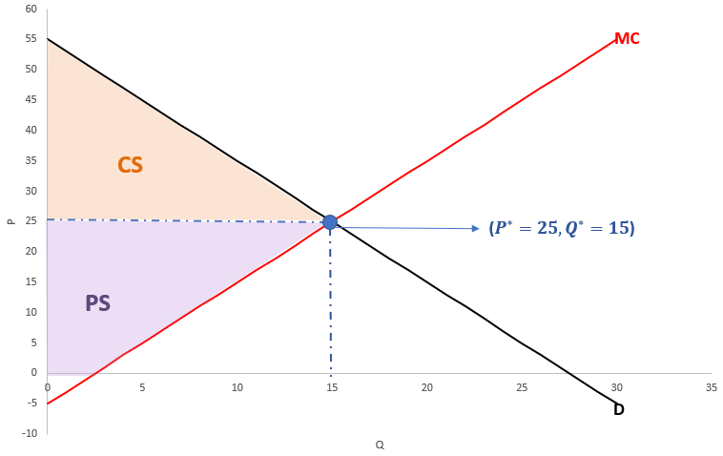
[note: the graph is showing the exact functional forms. This was not needed for full credit]

Consumer and producer surplus under monopoly:

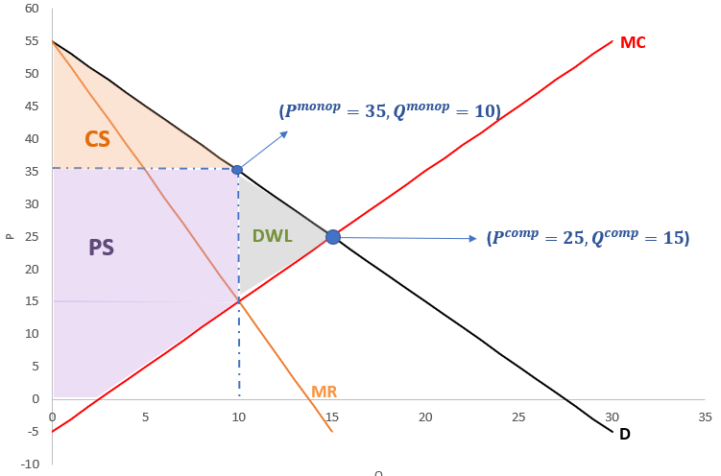

Graphically, the deadweight loss of the monopoly scenario (compared to the perfect competition scenario where P =MC=MR) is represented by the DWL triangle above. Under monopoly, consumers are worse off (lower CS), producers are better off (higher PS), and society overall is worse off because of the deadweight loss.

Problem 3. Reinventing Barnes & Noble (20 points)

- (5 points) Describe how the market for books has changed since the early 2000s. What do you think are the reasons for the decline in the fortunes of Barnes & Noble?

The market for books has changed since 2000, mostly because of competition from other companies (Amazon.com Inc.s Kindle, for example) and the availability of substitutes. One of the main reasons for the decline in the fortunes of Barnes & Noble is due to the fact that all bookstores are identical up and down the country and they did not meet local customers’ needs.

- (5 points) Consider the following three demand curves: Which one represents the best approximation for the demand Barnes & Noble faces and why? Use the concepts learned in class to describe the characteristics of the market in which Barnes & Noble operates.

The best approximation for the demand Barnes & Noble faces is:

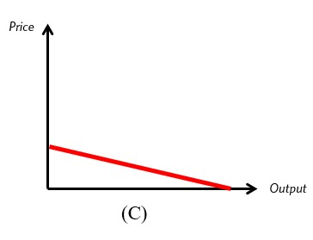

The market in which Barnes & Noble operates is a monopolistically competitive market. Monopolistically competitive market characteristics:
- There are many sellers
- Differences can be perceived between products, but they are close substitutes
- There are no or limited barriers to entry
- Profit can be positive/negative in the short run, but economic profits are zero in the long run

It differs from perfect competition since in perfect competition there is no product differentiation.

It differs from monopoly because in monopolies there is one seller, restricted access to entry, and there is only one product.

The market served by Barnes & Noble is not perfectly competitive because there is some product differentiation (their stores and products sold within the stores are different). For example, some bookstores have a café and comfortable chairs inside. Some bookstores specialize in certain genres of books.

- (5 points) What does this type of demand curve imply about the ability of Barnes & Noble to increase the price of its products?

The firm has some power to change the price of its product (more than in a perfectly competitive market where a firm can’t change the price, but less than in a monopolistic market). The firm could change the price but an increase in price will result in a sizable decrease in quantity demanded because of the relatively flat slope, making demand quite elastic. The final magnitude of this change will depend on the slope of the demand curve: the flatter the curve, the largest the change in quantity demanded as a response to a change in price.

- (5 points) In a recent interview, James Daunt proposed to give more freedom to the individual bookstores: “You should do what you want; there are no restrictions on what books you stock…Each bookshop is quite individual.” Propose two strategies for bookstores to differentiate themselves from competitors. What does differentiation imply for the price elasticity of demand?

Some ways of offering differentiated products to customers.
- Bookstores could specialize in a few genres of books, targeted to the interest/tastes of local consumers.
- Bookstores can offer more products and services to their customers, so they don’t just go to the stores to buy books. Customers can shop other related products such as magazines, stationary products, entertainment products, etc. Bookstores can also serve coffee and pastries inside the bookstores, so customers are more likely to spend more time there. We could turn the bookstores into a place where customer come not only to buy books when they need, but also to spend their days off enjoying coffee and reading books.

Differentiation will make the demand curve less elastic.

Problem 4. Avocado Pricing Strategy – 20 points

(5 points) What is the optimal price to charge in Atlanta? Show your work both analytically and graphically.

To find the optimal price, we need to set marginal revenue (MR) equal to marginal cost (MC).

First, derive the total revenue (TR) and MR from the demand function for Atlanta:

$$Q_{A}=730-175P_{A}$$

$$P_{A}=\frac{730-Q_{A}}{175}$$

$$TR=\frac{730}{175}Q_{A}-\frac{{Q_{A}}^{2}}{175}$$
Differentiate TR to get MR:
$${MR}_{A}=\frac{dTR}{dQ_{A}}=\frac{730}{175}-\frac{{2Q}_{A}}{175}$$Set MR equal to MC (given as 0.17):
$$\frac{730}{175}-\frac{{2Q}_{A}}{175}=0.17$$

$$Q_{A}=350.13$$
$$P_{A}=\frac{730-350.13}{175}$$

$$P_{A}=2.17$$Thus, the optimal price in Atlanta is $\$2.$17.
Graphical representation

(5 points) What is the optimal price to charge in San Diego? Show your work both analytically and graphically.

We follow the same steps as in a.
We derive the total revenue (TR) and MR from the demand function for San Diego:
$$Q_{B}=855-319P_{B}$$

$$P_{B}=\frac{855-Q_{B}}{319}$$
$$TR=\frac{855}{319}Q_{B}-\frac{{Q_{B}}^{2}}{319}$$

$$Differentiate TR to get MR:$$
$${MR}_{B}=\frac{dTR}{dQ_{B}}=\frac{855}{319}-\frac{{2Q}_{B}}{319}$$
$$Set MR equal to MC (given as 0.17):$$

$$\frac{855}{319}-\frac{{2Q}_{B}}{319}=0.17$$

$$Q_{B}=400.38$$
$$P_{B}=\frac{855-400.38}{319}$$

$$P_{B}=1.43 \\ Thus, the optimal price in$$San Diego is $1.43.

Graphical representation:

(3 points) What is the own-price elasticity of demand at the profit-maximizing prices in the two cities?

The formula for the own-price elasticity of demand is:
$$E_{D}=\frac{dQ}{dP}×\frac{P}{Q}$$For Atlanta:
From the demand function:
$$\frac{dQ_{A}}{dP_{A}}= -175$$

From question a) we have $P_{A}=2.17$ and $Q_{A}=350.13$

Hence: ${E_{D}}_{A}=-175*\frac{2.17}{350.13}=-1.08$
For San Diego:
From the demand function:
$$\frac{dQ_{B}}{dP_{B}}= -319$$

From question b) we have $P_{B}=1.43$ and $Q_{B}=400.38$
Hence: ${E_{D}}_{B}=-319*\frac{1.43}{400.38}=-1.14$

(4 points) Do your findings in a. and b. (price in each market) and in c. (own-price elasticity in each market) confirm what we learned in class about elasticities and price discrimination?

Yes, they do. We learned that everything else being equal, we want to charge higher prices in less elastic markets, which is Atlanta in this exercise.

(3 points) Explain which problems may result from the pricing structure that you have calculated in the previous questions. [A quantitative answer is not required. Hint: What if transportation costs are low relative to price differences?]

This may lead to the problem of "Parallel Imports". Selling the same item at different prices may result in traders purchasing at the lower price in San Diego and shipping the avocados to Atlanta, where the price is higher. That threat would undercut the firm’s pricing policy and may cause them to abandon the price discrimination scheme.

Problem 5. Working Interactively with AI: The Future of Work (15 points)
Welcome to the AI & Labor Market Challenge.

Step 1 (2 points) — Choosing the Occupations

For this solution, we focus on two occupations that are quite different from each other in terms of daily activities and required skills:
- Lawyers (SOC 23-1011.00)
- Human Resources Managers (SOC 11-3121.00)
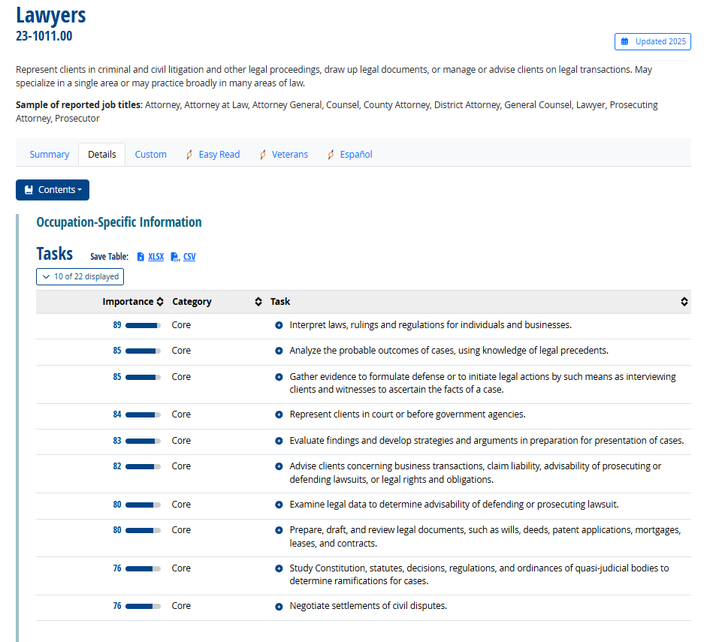
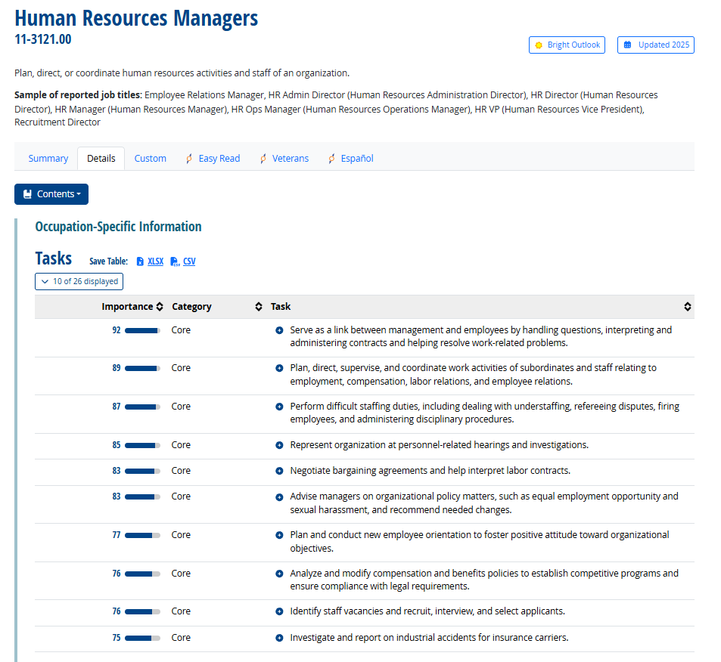

Step 2 (5 points) — Listing and Classifying Tasks

Table for Lawyers
Importance | Task | AI-replacement
A |  | B | AxB
89 | Interpret laws, rulings, and regulations for individuals and businesses. | 1 | 89
85 | Analyze the probable outcomes of cases, using knowledge of legal precedents. | 1 | 85
85 | Gather evidence to formulate defense or initiate legal actions (e.g. interviewing clients and witnesses). | 1 | 85
84 | Represent clients in court or before government agencies. | 0 | 0
83 | Evaluate findings and develop strategies and arguments in preparation for cases. | 0 | 0
82 | Advise clients concerning business transactions, liability, or legal rights and obligations. | 0 | 0
80 | Examine legal data to determine advisability of defending or prosecuting lawsuits. | 1 | 80
80 | Prepare, draft, and review legal documents (e.g. wills, deeds, patents, mortgages, leases, contracts). | 1 | 80
76 | Study Constitution, statutes, decisions, and ordinances to determine case ramifications. | 1 | 76
76 | Negotiate settlements of civil disputes. | 0 | 0
820 |  |  | 495

Table for Human Resources Manager

Importance | Task | AI-replacement
A |  | B | AxB
92 | Serve as a link between management and employees by handling questions and resolving problems. | 0 | 0
89 | Plan, direct, supervise, and coordinate work activities related to employment and labor relations. | 0 | 0
87 | Perform staffing duties (e.g. recruiting, interviewing, hiring, disciplinary procedures). | 0 | 0
85 | Represent organization at personnel-related hearings and investigations. | 0 | 0
83 | Negotiate bargaining agreements and interpret labor contracts. | 0 | 0
83 | Advise managers on policy matters (e.g. EEO and sexual harassment). | 0 | 0
77 | Plan and conduct new employee orientation programs. | 1 | 77
76 | Analyze and modify compensation and benefits policies to ensure compliance and competitiveness. | 1 | 76
76 | Identify staff vacancies and recruit, interview, and select applicants. | 1 | 76
75 | Investigate and report on industrial accidents for insurance carriers. | 1 | 75
823 |  |  | 304

Step 3 (8 points) — Computing the AI-Replacement Index
AI Replacement Index = $Σ(Importance × Replacement dummy) / Σ(Importance)$,

where $\text{Σ}$ indicates “sum”.

Occupation | Calculation | Weighted AI Replacement Index
Lawyers | 495÷820 | 0.6
HR Managers | 304÷823 | 0.37

This result suggests that a majority of core legal tasks – particularly those involving document drafting, legal research, precedent analysis, and evidence review – could be automated or significantly accelerated by AI tools such as large-language-model legal assistants and automated document-search platforms. These systems can process vast texts and produce legal drafts much faster than humans.
In contrast, HR managers’ work remains more resistant to full automation. While AI can support recruiting (resume screening, scheduling interviews, analyzing turnover data), much of the role requires nuanced human interaction – resolving conflicts, negotiating agreements, motivating teams, and building trust within organizations – tasks that rely on empathy, judgment, and communication skills that current AI cannot replicate effectively.
At first glance, it may seem surprising that Lawyers score higher in exposure than HR Managers, since legal work is often perceived as specialized and knowledge-intensive. However, this result aligns with the idea that AI excels at structured, text-based cognitive tasks. The legal profession generates enormous quantities of documents, precedents, and standardized forms that can be processed algorithmically.
By contrast, Human Resources Managers perform tasks that are relational, situational, and often emotional – attributes less easily codified into rules or patterns. AI may assist HR professionals by automating administrative work, but the human component of decision-making remains central.

